Changes

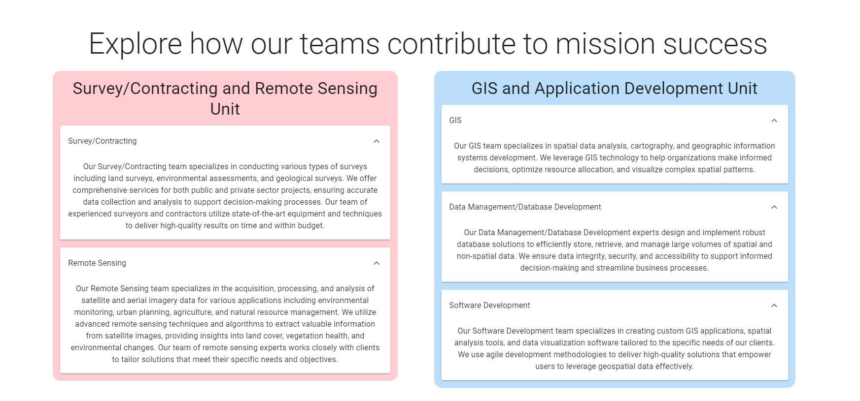

Add link to read more.

Read more will go to Landing page info.

**Note**: Landing page will be removed, and all projects will be in a single page.

Landing page will be an information page will project and apps being removed from the top.

**Read more Page look:**

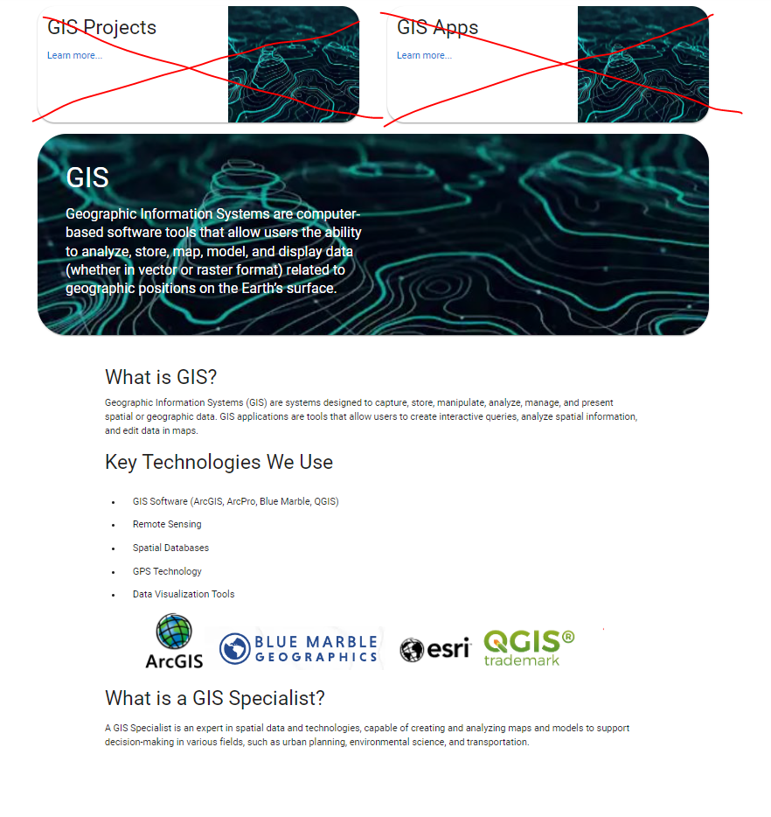

1. Projects

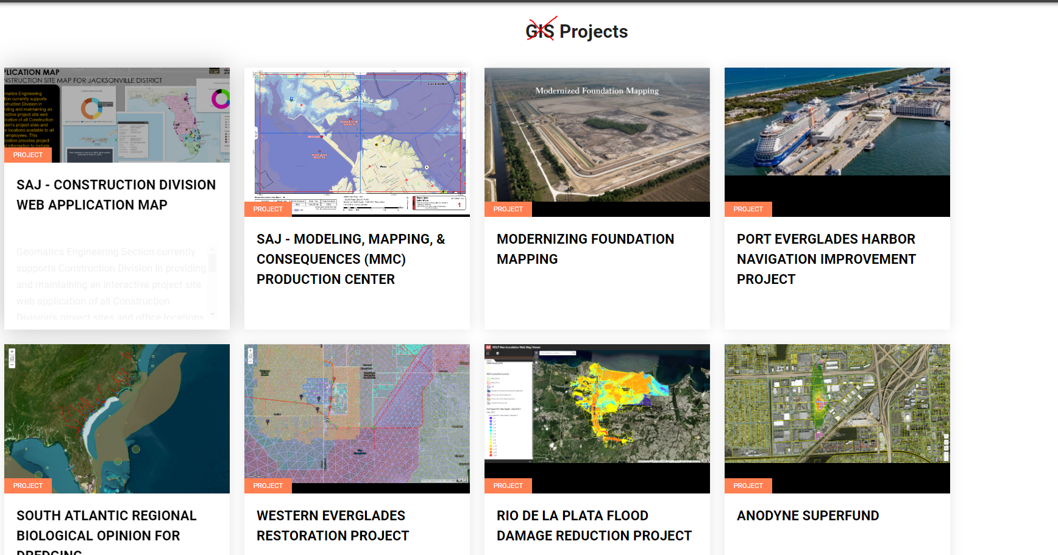

This page will contain a filter with the following data:

* View All
* Jacksonville Civil Works
* Emergency Management
* National and Other District Support

Add a basic search.

1. 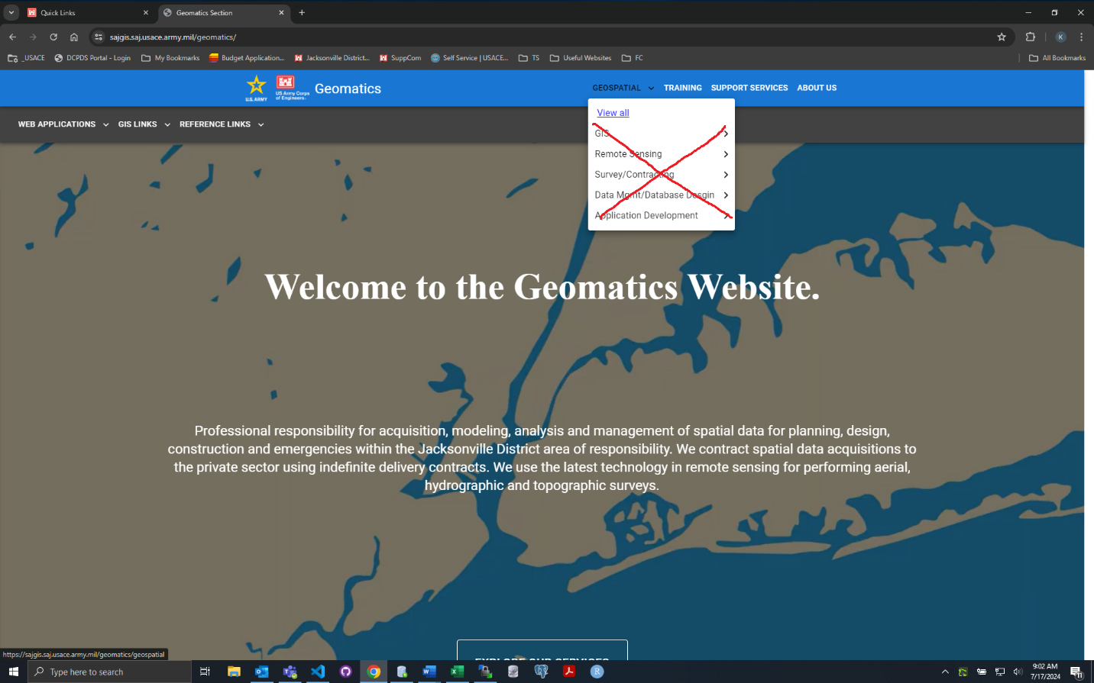

Geospatial will contain Projects and Applications.

1. 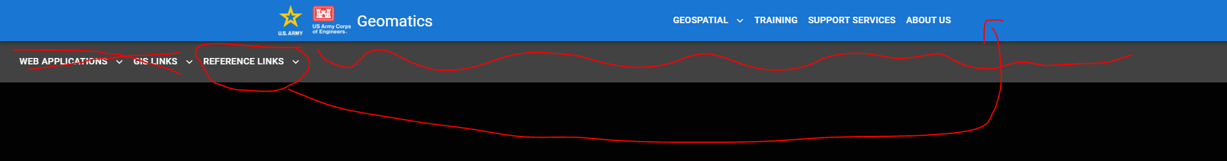

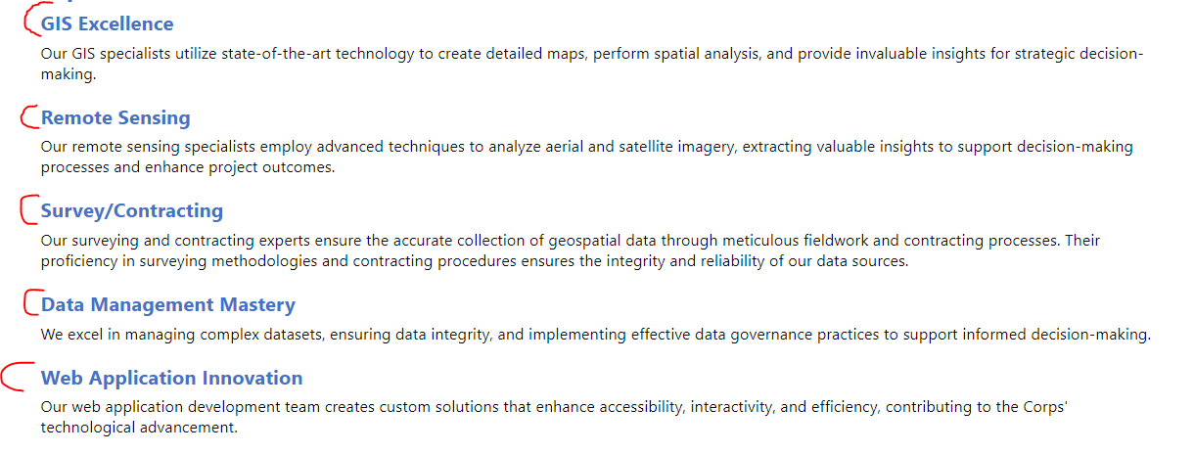

Make URLs to go to Landing Page info.